|  |
| --- |
| **TurnQuest Everest Insurance Suite**  **General Insurance System(GIS)**  **User Manual** |



**25th June 2014**

**Table of Contents**

**ORGANIZATION SETUP**

Organizations

Countries

Country Information

Country Holidays

Hierarchy

ORGANIZATION PARAMETERS

User Parameters

Currencies

Currency Rates

Required Documents

Payment Modes

Claims Payment Modes

Printer Setups

Sequences

System Applicable Areas

ECM Parameters

Email/ECM Reports

Account Management

Client Types

Client Loading

Client Titles

Agency Classification

Agency Loading

Sectors

Service Provider Types

Service Provider

ACTIVITY MANAGEMENT

Activity Statuses

Activity Types

Activities

CAMPAIGN MANAGEMENT

Campaigns

Client Attributes

Product Attributes

Leads and Potentials

Lead Sources

Lead Statuses

Leads

SERVICE REQUESTS

Request Categories

Service Desk

Requests Tracking

Request History

MESSAGING

Scheduler

Message Template

Single Message

Mobile Service Providers

Memorandum Setups

Mail Settings

SMS Settings

BANK SETUPS

Banks

# ORGANIZATION SETUP

All the organization setup parameters are accessed via this Module.

#### Summarized Process

*Login to CRM>>Select Organization Setups>>Organogram>>Organizations>>Click New>> Enter Details>>Save*

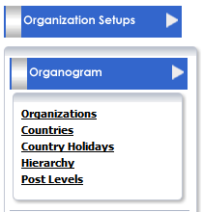

For a user to be able to do any organization setup in the system he/ she must be assigned the setup access roles to a particular screen.

### Organizations

This screen is used to define the different organization in the insurance company.

In Turn Quest LMS and GIS are defined as separate organizations.

#### Organization Creation

Login to CRM>>Select Account Management >>*Org Setups>>Organizations>>Click New>> Enter Details.*

*On clicking new the screen below is displayed;*

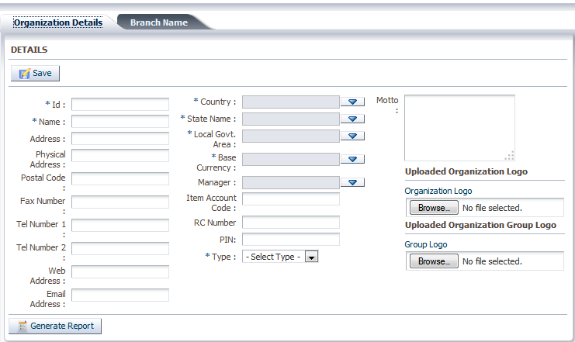

*Fields that have been *(Asterix) are Mandatory*

#### Organization details

**Id**-This is the organization short description

**Name**-This is the name of the organization

**Address-**Postal address of the Organization

**Physical address-**Location of the organization

**Postal code –**Post office code for the postal address

**Fax Number**-Facsimile number for the organization

**Tel Number 1-** Telephone contact of the organization

**Tel Number 2-**Telephone contact of the organization

**Web Address-**website of the organization

**Country-**country of the organization

**State Name-**State where the organization is located.

**Local Govt Area-**Town where the organization is located

**Base Currency-**The organization currency

**Manager-**Manager in charge of the organization

**Motto-**Motto of the organization

#### Branch Name

Select the organization you want to create the branch under and click on new. The screen below is displayed;

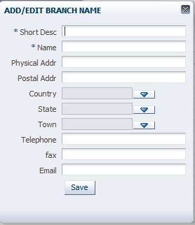

## Countries

This screen is used to define countries used across the Turn Quest application.

#### Creating New Country

Click New, the screen below is displayed to enter the country information for a specific country.

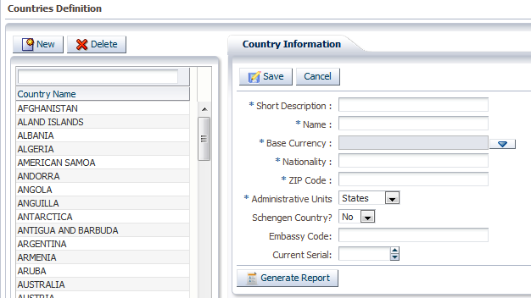

### Country Information

Short Description-Short description of the country

Name-Name of the country

Base currency-Currency in use on that particular country

Nationality –E.G KENYAN

ZIP Code-Zip code of that particular country

Administrative Units-What administrative units is the country divided e.g COUNTIES

Schengen Country?-If the country is schengen or not(countries that have abolished passport or any other type of border control in-between their common borders, also referred to as internal borders)

Embassy Code-what is the embassy code of that particular country

## Country Holidays

This is a screen to define all the holidays in each country.

**Creating Country Holiday**

Select the country and click new to create a new holiday under that particular country.

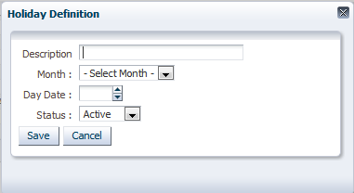

**Country Holiday Information**

**Description-**The kind of holiday e.g. Labor day

**Month-**The month of the holiday

**Day Date-**The date of the holiday

**Status-**Either Active or inactive

## Hierarchy

Turn Quest CRM > Org Setup>Hierarchy > Select the General Insurance System

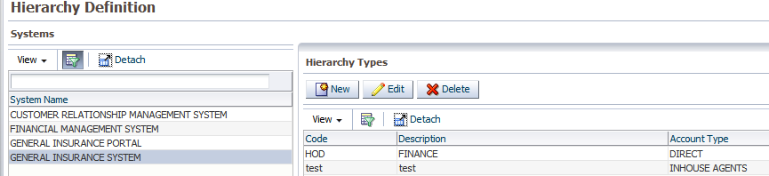

Define the hierarchy type i.e. Agents Hierarchy and Marketers (Staff) Hierarchy

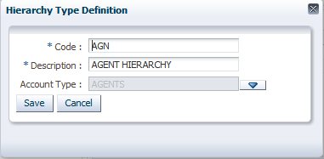

Select the new hierarchy type and click on new under Hierarchy Levels

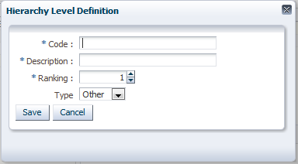

Using the organization structure based on the analysis document, define the different levels

#### Department level

This is for example GENERAL INSURANCE department

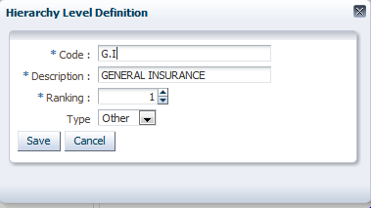

#### Branches Level

This is basically following the structure given for agents in the analysis document:

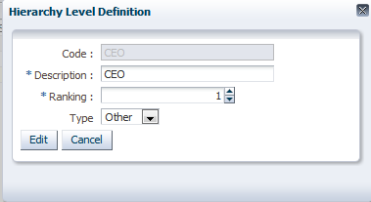

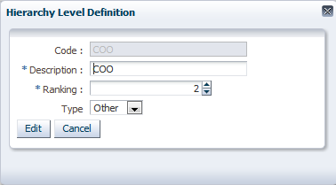

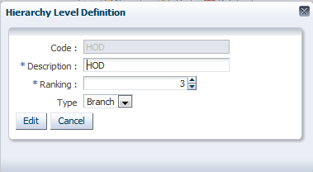

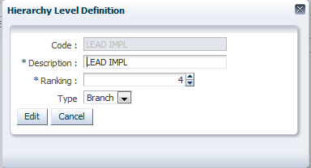

After the above setup you should have the structure as shown below

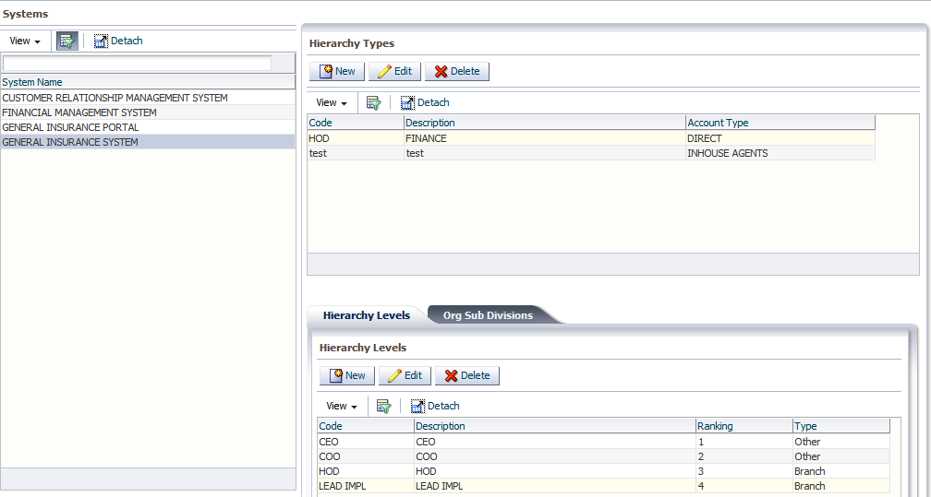

#### Agent Hierarchy Subdivisions

Start building from the highest level, highlight the General Insurance department, then click on ‘Org Sub Divisions’ tab

#### General Insurance Level

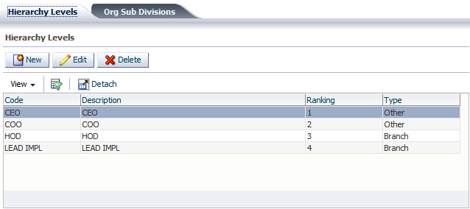

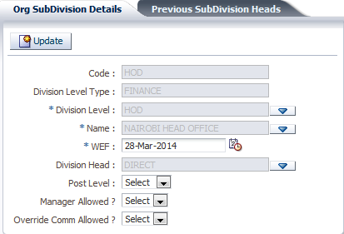

* Place a code,
* The Division Level type is the hierarchy type defined above.
* The Division level, select the levels sequential starting with level 1
* Type the name which should represent the item keyed in
* Enter the WEF date and save

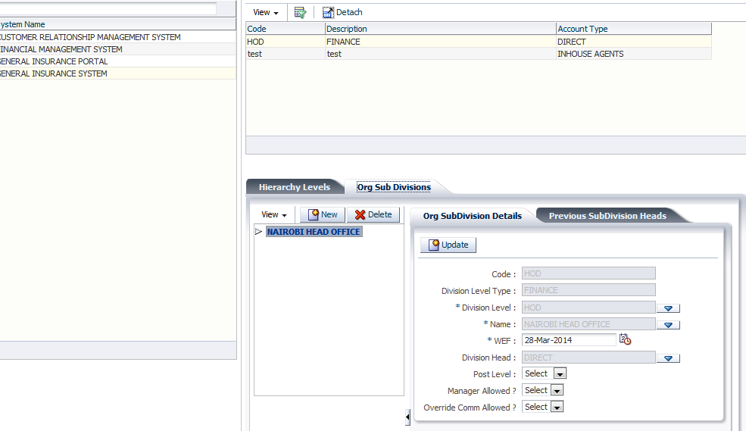The hierarchy is created to the left, Click on the item and click on NEW to define the levels below it.

## ORGANIZATION PARAMETERS

### User Parameters

**This is the screen used to define all the parameters used in the CRM system. E.g. enabling SMS**

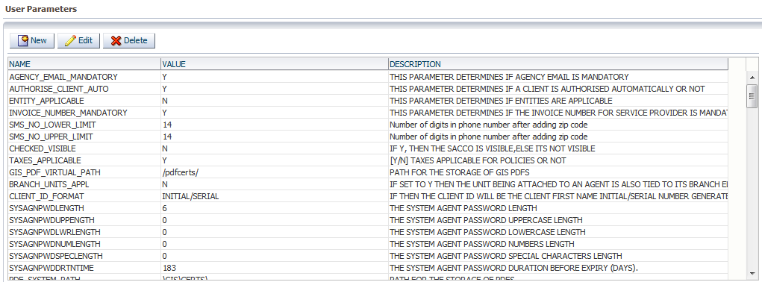

### Currencies

This screen is used to define the currencies and currency Denominations

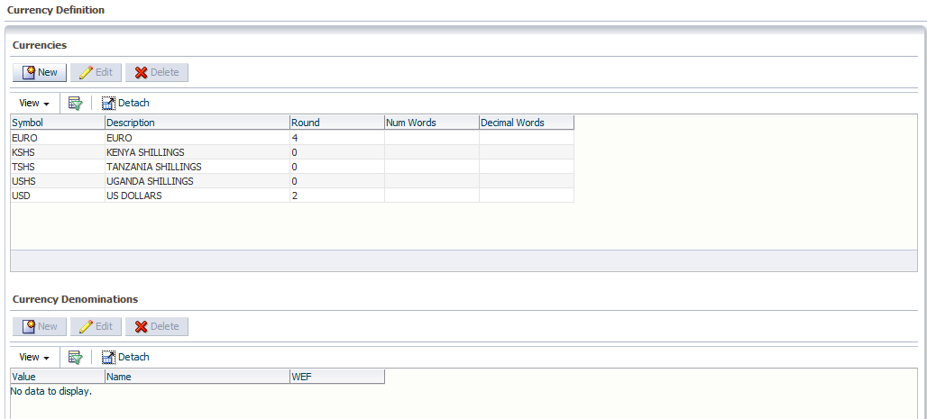

#### Creating New Currency

**Click on New the screen below is displayed**

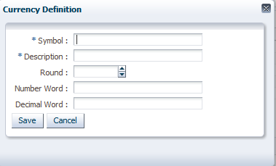

**New currency Info**

**Symbol-**The symbol representing the currency

Description-the description of that currency

Round-the decimal places figures e.g. premium to be rounded to

Number Word-E.g. Kenya Shillings

Decimal Word-e.g. Shilling

**Creating New Currency Denominations**

Click on New the screen below is displayed

**New Currency Denominations Info**

**Value**- value of the currency denomination

**Name** –Name of the currency denomination

WEF Date-This is the with effect date of the currency denomination

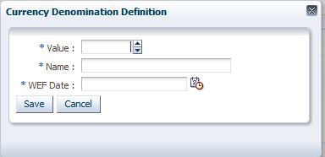

### Currency Rates

This is the screen used to define the exchange rates of different currencies.

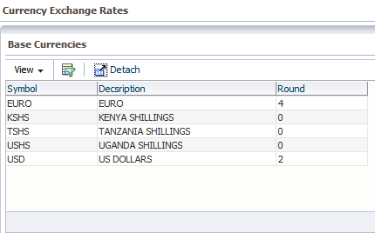

#### Adding a New Currency Exchange Rates

Select the currency you want to key in the currency exchange rate.

The screen below is displayed;

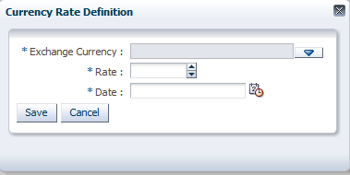

**Currency Exchange Rates**

**Exchange Currency-**The currency you are defining exchange rate for

**Rate-**The exchange rate

**Date-**Date the exchange rate to be used

### Required Documents

This is a screen used to define the document which must be submitted before a client is created e.g. IDENTIFICATION CARD.

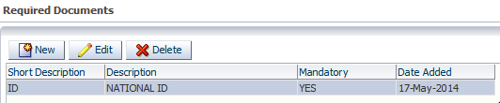

#### Adding a new document

Click on new button the screen below is displayed

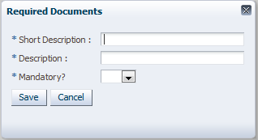

**Required Documents Information**

Short Description-Short code of the document

Description-Elaborate description of the document name

Mandatory-specify if the document is mandatory to be provided or not

### Payment Modes

This is a screen used to define all the payment modes used in underwriting.

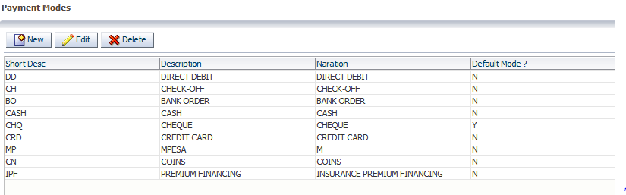

#### Adding a new Payment Mode

Click on new the screen below is displayed

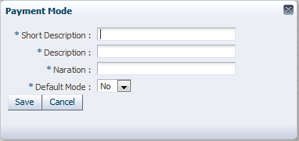

#### Payment mode Information

Short description-short description of the payment mode

Description-A description of the payment mode

Narration-Detailed narration of the payment mode

Default- Specify if the payment mode to be used will be default or not.

### Claims Payment Modes

This screen is used to define all payment modes used to during claim processing.

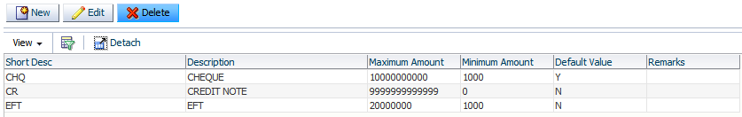

#### Adding a new claim payment mode

Click new the screen below is displayed

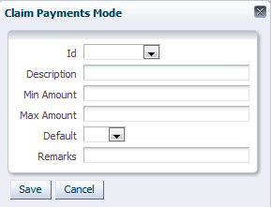

#### Claim Payment mode Information

ID-Short description of the payment mode

Description-Description of the payment mode

Minimum amount-The minimum amount which can be paid using any specific mode

Maximum amount-The Maximum amount which can be paid using any specific mode

Default-If the payment mode is default or not

Remarks-Narration of the payment mode

### Printer Setups

This is a screen which enables the user to setup the printer server settings that will be used.

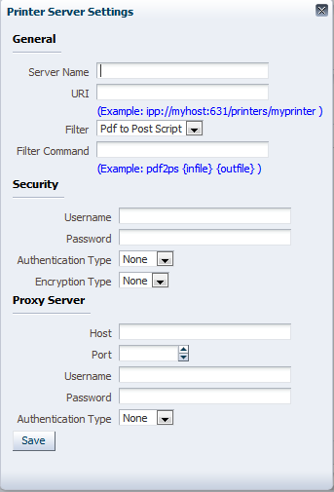

### Sequences

This is a screen which displays all the CRM Sequence e.g. client sequence.

These records are automatically added on the screen and no new record can be added on the screen, that’s why the new button is disabled.

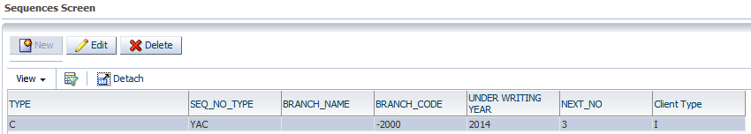

### System Applicable Areas

This screen is used to define where the CRM setup will be applicable.

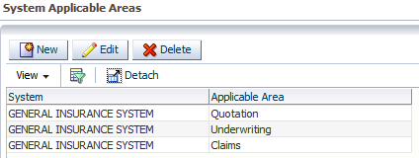

### ECM Parameters

This screen is used for document management.

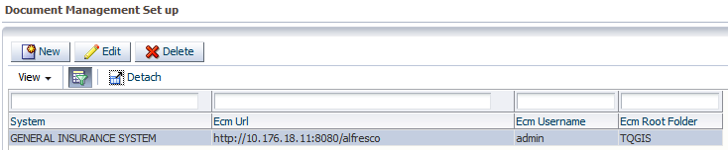

### Email/ECM Reports

This is where you select the system you are using to transact e.g. General Insurance System

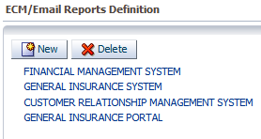

#### Process

After selecting the system, you click on the process/transaction type

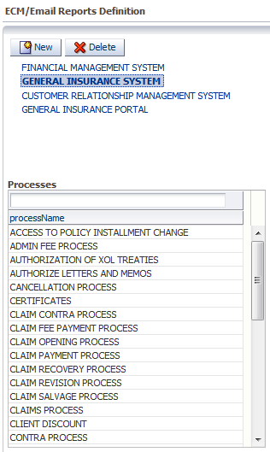

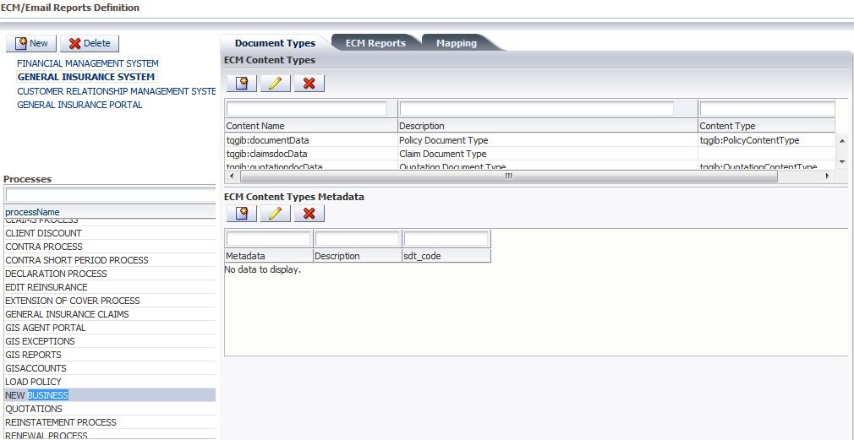

Once you have selected the process, you can define the documents you will use for the particular process.

#### ECM Content Types Metadata

This screen is used to define the content types of the defined documents for the selected process.

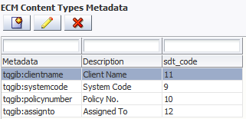

## Account Management

The Accounts Management module in Turn Quest Client Management System (CRM) is used to manage the Different Account Types, Prospects, Clients and Service Providers

#### Summarized Process

*Login to CRM>>Select Account Management >> Accounts >> Select Account Type>> Click New>> Enter Details>>Save>> Search for the Account Created>> Assign System*

#### Account Creation

To create, edit, enquire on different intermediaries i.e. Agents, Brokers, Sub Agents, Insurance companies, Reinsurance companies, Facultative In, Facultative –out ,Direct Agents in the system the accounts

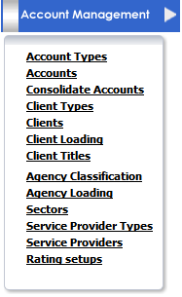

Login to CRM>>Select Account Management >> Accounts >>

The screen below is displayed

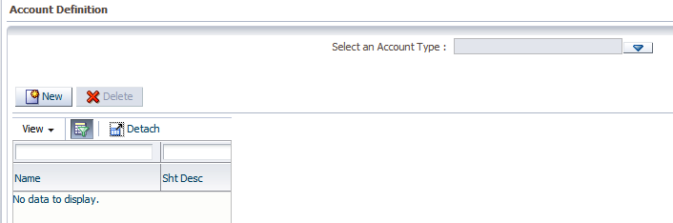

First select an Account Type from the predefined list

*Creating New Agent/Direct/Broker/Insurance Company/ Reinsurance Company/ Marketer/ Fac-In/ Fac-Out/Direct Agents*

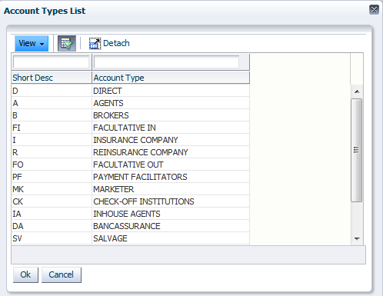

Select account Type Agent and click Ok

Click on New the Accounts Details screen

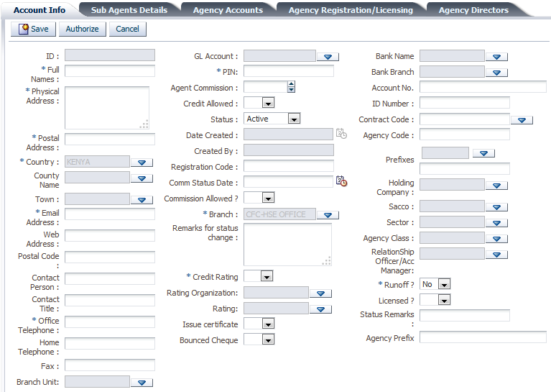

*Fields that have been *(Asterix) are Mandatory*

#### Accounts Info

**Id:** This is automatically generated by the system this is the agent short description

**Full Names:** Agents full names

**Physical Address:** Physical Address of the agent

**Postal Address:** Postal Address of the Agent

**Country, State, Town:**Intermediary Country,County and Town

**Email Address and Web Address:** Email and Web address for the intermediary

**Postal Code:** Postal Code **e.g 0200**

**Contact Person and Title: contact person in the created Account**

**Office, Home Telephone and Fax number**

**Pin:** Agents Pin Number

**Branch:** Defaults to the user branch

**Remarks for status change:** Incase the status of the intermediary has change to Inactive

**Credit rating:** International Rating for agents

**Bank Name, Bank Branch and Account Number:** Bank account details of Agent

**Id Number:** Agent Identification Number

**Sms No:** Short message number

**Holding Company:**Select the Holding company if intermediary is attached to a Holding company

**Sector:** List of Sectors

**Run Off:** If Y Account has been black listed

**Licensed:** If set to N an exception will always be raised when the Agent not licensed is used in transaction

The same process applies to all the account types defined previously.

#### Sub Agents Details

This tab lists all sub agents attached to the Main Agent or Broker

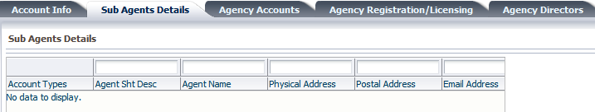

#### Agency Accounts

The screen below is used to define several accounts that an agent can have. This depends with the organization structure whereby there is the introduction of Divisions and the Agent will be tied to a specific division specified at the organization level

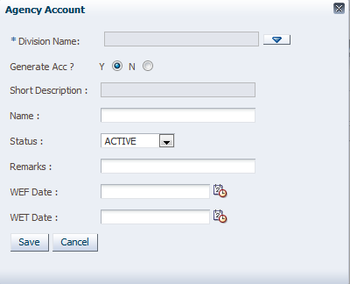

#### Agency Registration/ licensing

The screen below is used to enter the Registration details of the Agent

Year, Registration Number, Registered period (W.e.f to W.e.t dates) and Registration Accepted

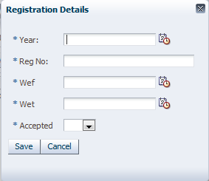

#### Agency Directors

This screen is for defining the directors in the Account created

Details required are the Year, Name, professional Qualifications, and Percentage of share holding

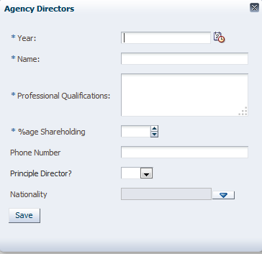

#### Agency Referees

This screen is for defining the Account referees

Details required are Name Physical Address, Postal Address, Id No, Email and Telephone Number

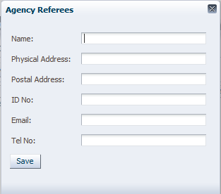

#### Account Systems

The screen below is used to assign the Account created to a system. For an agent to be used in transactions in The General Insurance System they need to be assigned the system

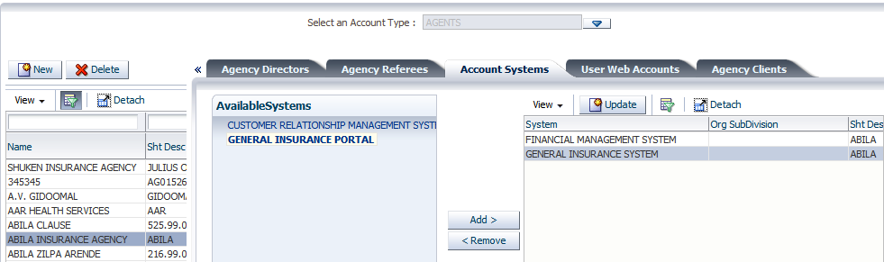

**Note:** If System is not assigned to the agent you will not be able to get the Agent in any system for transactions

#### User Web Accounts

Only applicable when there is an Turn Quest Agents Portal System (A System that enable Agents to connect to their portfolio)

This is the Administration screen for creating the user names and password for the agents in order to connect to the Turn Quest Agents Portal

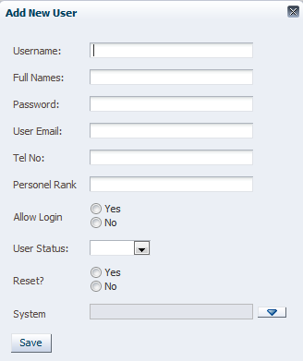

#### Agency Clients

This screen lists all the Clients that are attached to the selected agent

The list automatically updates for clients attached to the Intermediary

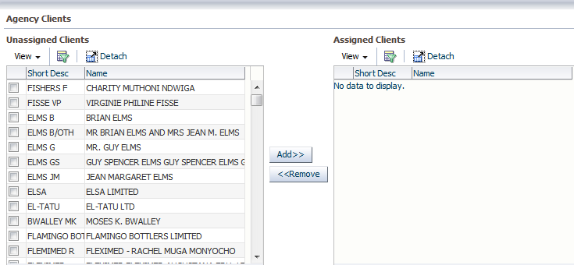

### [ClientTypes](http://10.176.18.11:5000/CRMNEW1/faces/MobileSmsMessages.jspx?_adf.ctrl-state=10yc1w5tbl_4)

**This screen is used to define the different types we have e.g. individual**

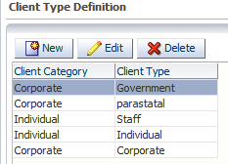

#### Creating a New client type

Click on new the screen below is displayed

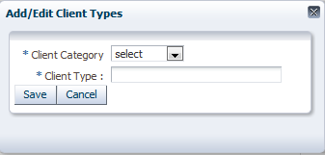

#### Client Type Information

**Client Category –**which category belongs to

**Client type-**which client type

#### CLIENTS

This screen is used to define all the clients to be used across the systems

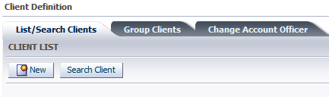

#### CREATING A NEW CLIENT

Click on the new button the screen below is displayed

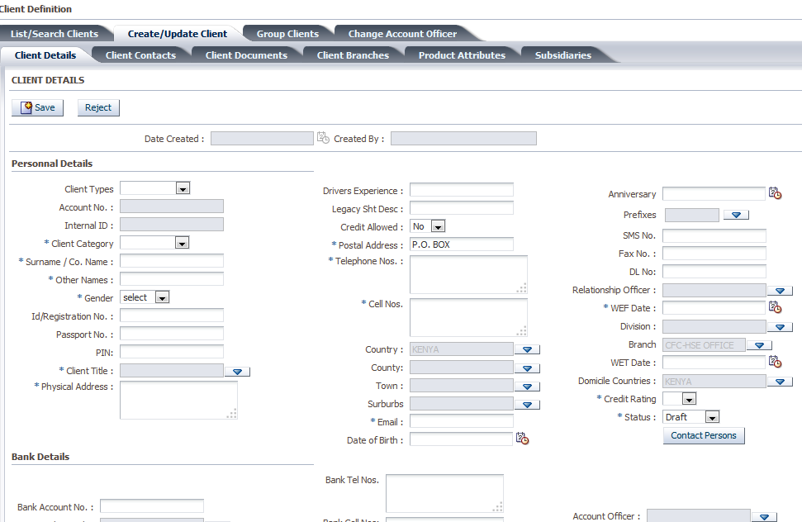

*Fields that have been *(Asterix) are Mandatory*

#### Clients Info

**Personal Details-**These contains all personal details

**Bank Details-**This includes bank details of the client

**Employment Details-**Details relating to employment of the client

**Additional Details-**Any other details of the client

After the above details are keyed in click on the save button then click on the authorize button to authorize the client after which you assign the client to a system

#### GROUP CLIENTS

This is used to group a number of clients in one group based on a certain criteria e.g. the Premium the pay.

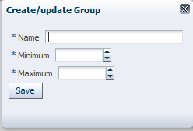

#### Change Account Officer

This is used to change the account officer for more than one client

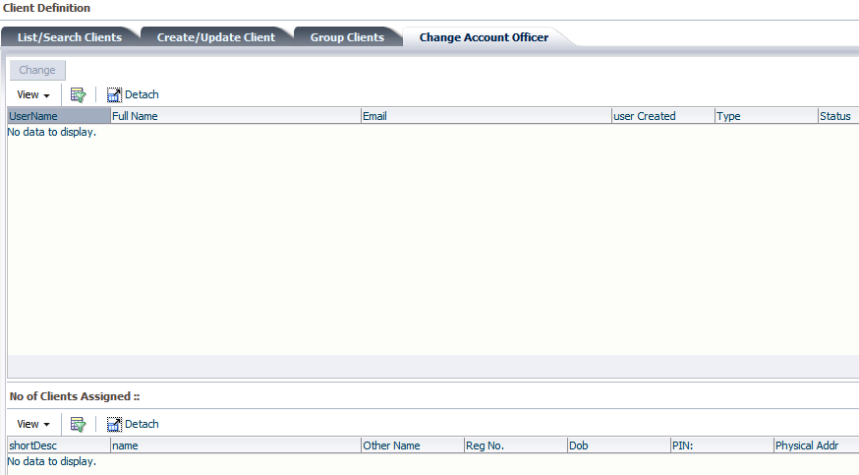

### Client Loading

This screen is used to view the clients who have been loaded into the system or not and also assign or unassigned them to the various systems e.g. GIS/LMS

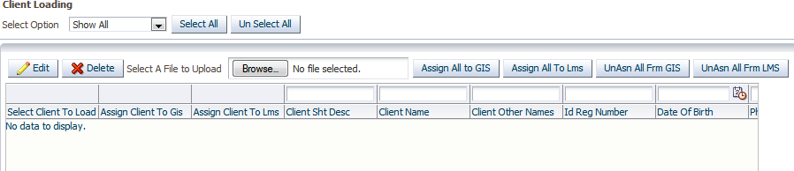

### Client Titles

This screen is used to define the various client titles to be used while transacting.

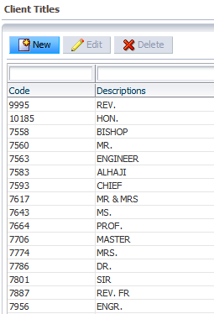

### Agency Classification

This screen is used to classify the various agencies to be used while transacting.

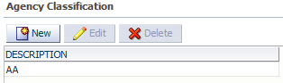

### Agency Loading

This screen is used to view the agencies which have been loaded into the system or not and also assign or unassign them to the various systems e.g. GIS/LMS

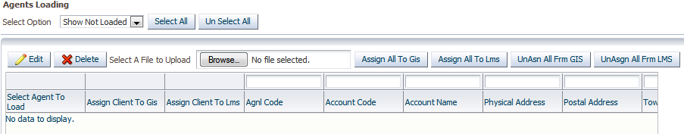

### Sectors

This screen is used to define the various sectors to be used when transacting

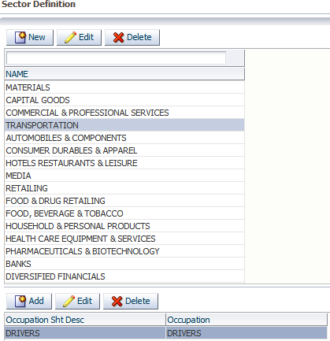

### Service Provider Types

This screen is used to define the various service providers to be used when transacting and their various activities.

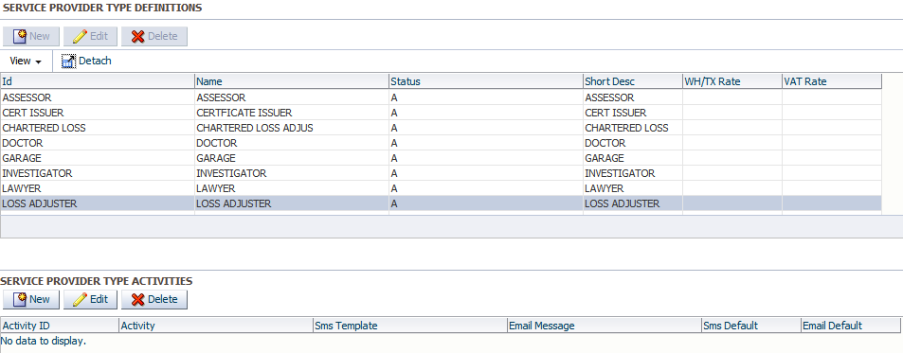

### Service Provider

This screen is used to define new service providers under the various service provider types defined previously. Location login to crm>>organization setup>>account management>>service provider>>select service provider type and click on new

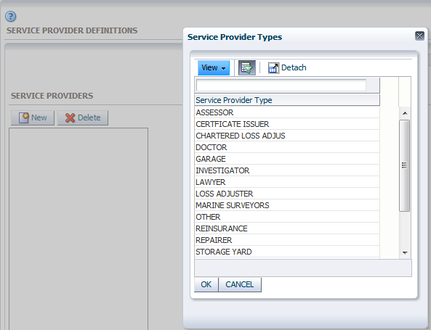

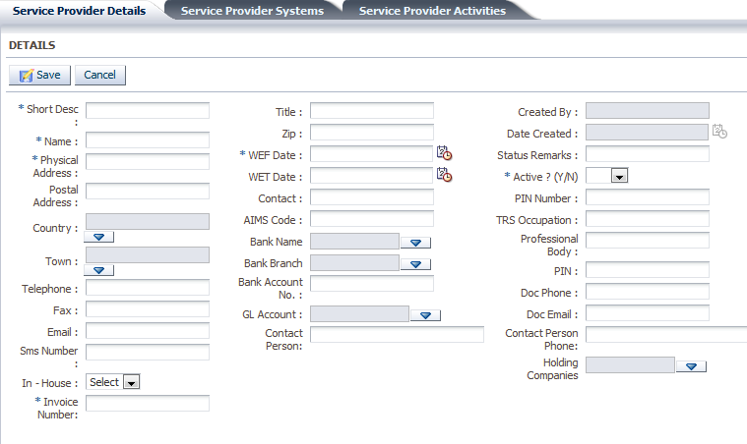

Fill in the mandatory fields and save.

#### Service Provider Systems

This screen is used to select the systems in which the service provider will be applicable.

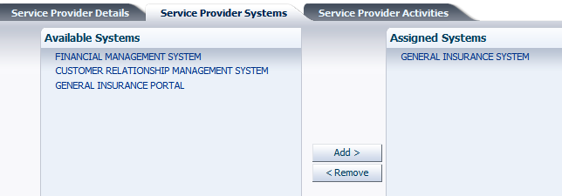

## ACTIVITY MANAGEMENT

### [Activity Statuses](http://10.176.18.11:5000/CRMNEW1/faces/serviceRequests.jspx?_adf.ctrl-state=gcj8y7l3s_4)

This screen is used to define the different status of the activity

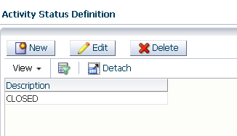

#### Adding a new activity status

Click on new the screen below is displayed.

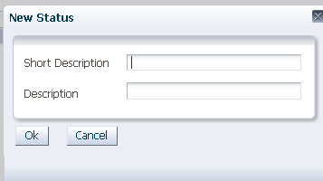

Information Required

**Short Description**-A short description of the activity status

**Description**-description of the activity status

**Activity Priority Levels**

This screen is used to define the level of priority of an activity.

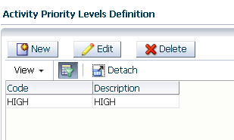

Adding a New Activity Priority Levels

Click on new the screen below is displayed

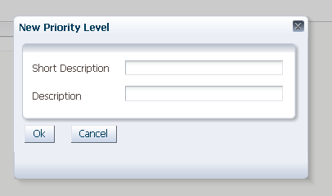

**Info**

**Short Description-**short description of the activity of the priority

**Description-**Description of the priority levels

### Activity Types

This screen is used to define the different types of activity we have under each organization.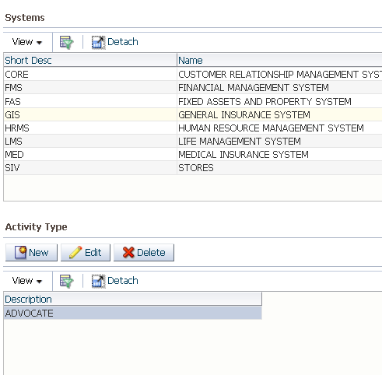

#### Adding a New Activity

Click on new the screen below is displayed

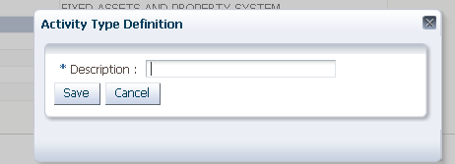

**Info**

Description-Description of the activity type

### Activities

This screen is used to define the activities taking place.

A reminder can sent for the same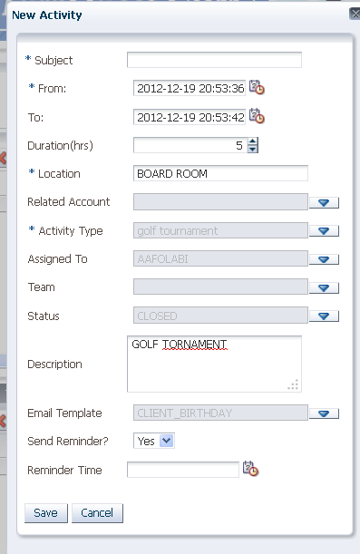

## 

## CAMPAIGN MANAGEMENT

### Campaigns

This screen is used to define the campaigns which take place in an organization

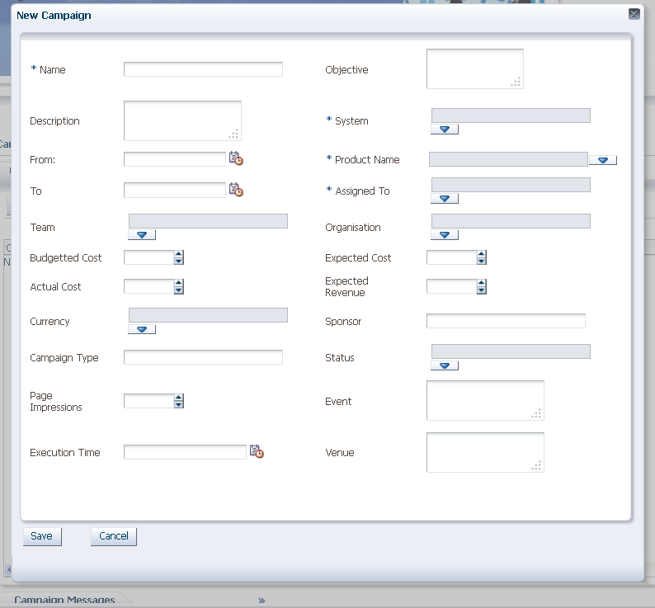

Once you have filled all the fields you can go ahead and define the campaign messages that will be sent to the various targets, the campaign targets, activities and products

### Client Attributes

This screen is where you can define the client attributes in relation to the necessary details required for the campaign.

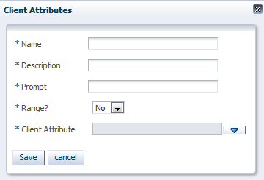

### Product Attributes

This screen is where you define the products to be used during the campaign and their various attributes.

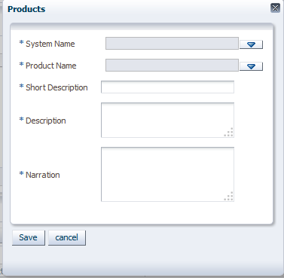

## Leads and Potentials

### Lead Sources

This screen is used to define the different sources of leads.

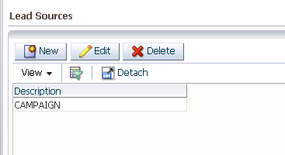

To add a new lead source click on new and add the description of the lead source.

### [Lead Statuses](http://10.176.18.11:5000/CRMNEW1/faces/leads.jspx?_adf.ctrl-state=4k7nd4spd_4)

This screen is used to define the different status of leads.

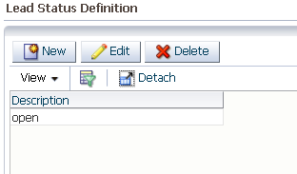

To add a new lead status click on new and add the description of the lead status.

### Leads

This is the screen where you define the lead either a company or any individual

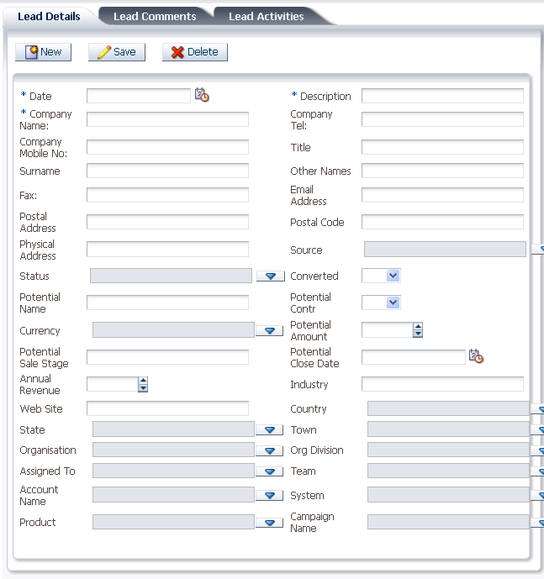

The lead comments tab is used to add any comment pertain that lead.

The lead activities are used to define the activities for the lead.

## SERVICE REQUESTS

This module is used to track all the requests from client, agents’ service providers to the organizations. These requests include complaints, premium payable, reporting claims e.tc

### Request Categories

This screen is used to define the different categories of request

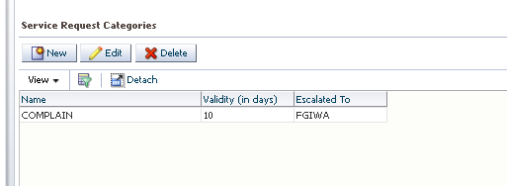

### [Service Desk](http://10.176.18.11:5000/CRMNEW1/faces/clients.jspx?_adf.ctrl-state=rvxjtzf8g_4)

This is a screen where all the requests are recorded

**Creating a new request**

Select the source of request e.g. Clients, agents or service provider

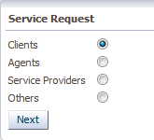

On click next the screen below is displayed

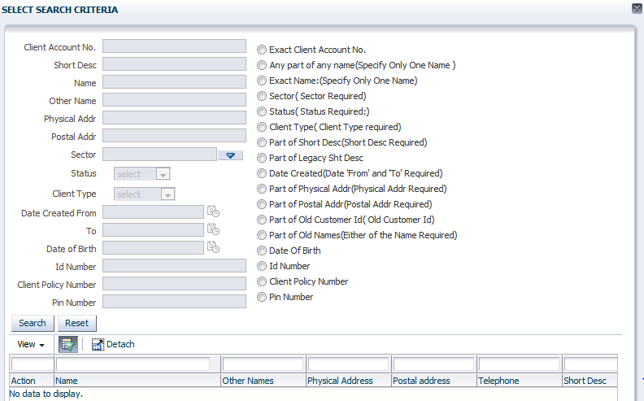

Search for the client who has made a request

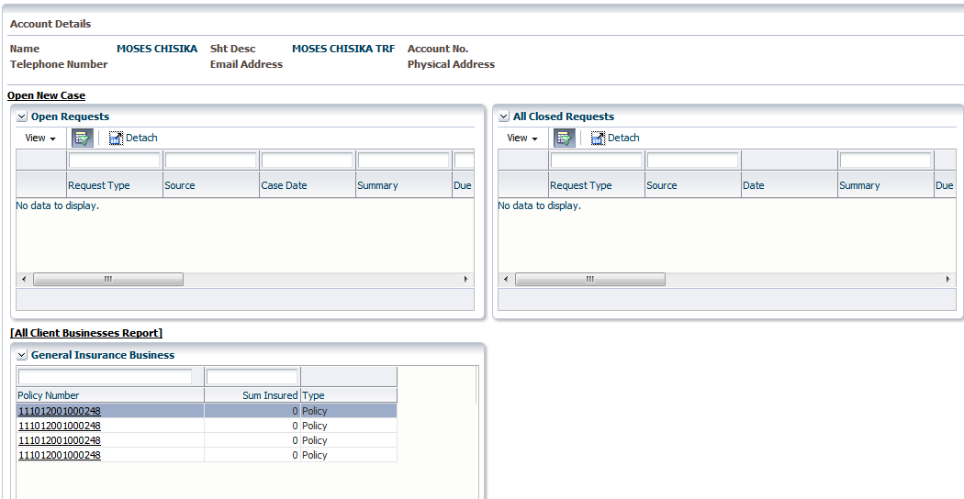

Click on new case

The screen below is displayed.

Enter the details of the new request on the screen below and save

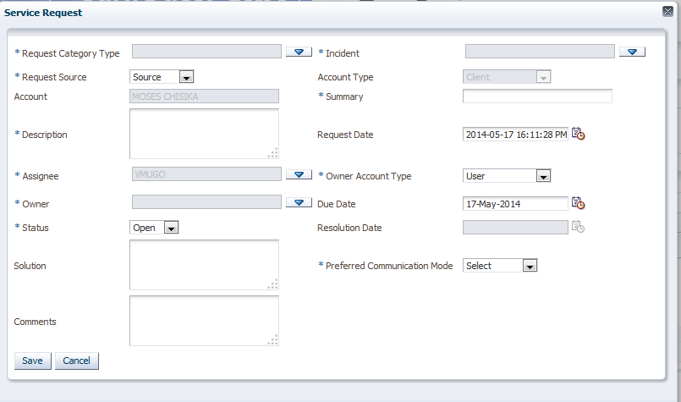

### [Requests Tracking](http://10.176.18.11:5000/CRMNEW1/faces/serviceRequests.jspx?_adf.ctrl-state=d7dxu3b47_4)

This screen displays all the requests made

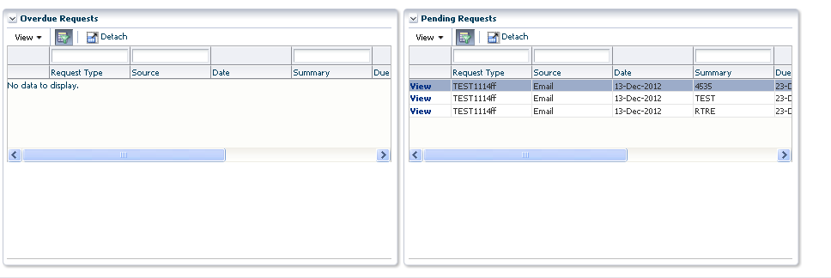

### Request History

This screen shows all the reports for request

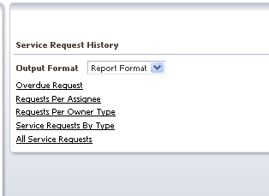

## MESSAGING

### Scheduler

This is used to send reminders as per specified parameters under the each system.

E.g. Client birthday as per the set job

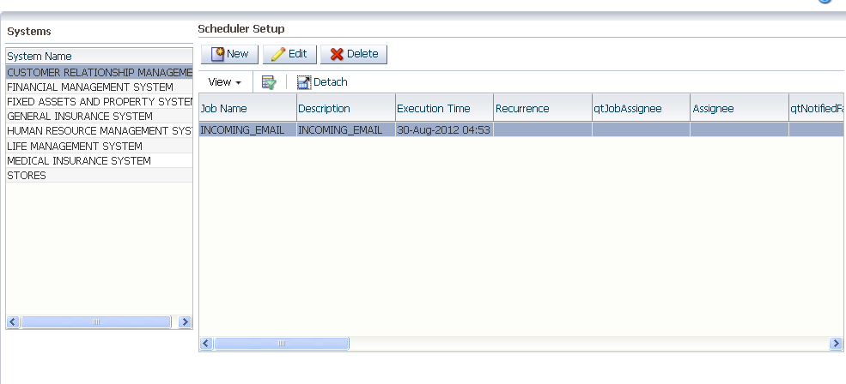

### Message Template

This screen is used to define the different message to be set from the system and the formats of the message e.g. a message to notify the client that her policy is due for renewal.

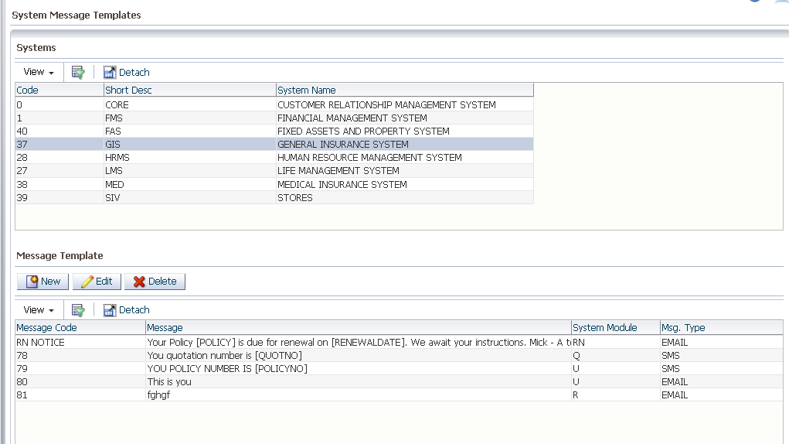

### Single Message

This screen is used to send one message at a time

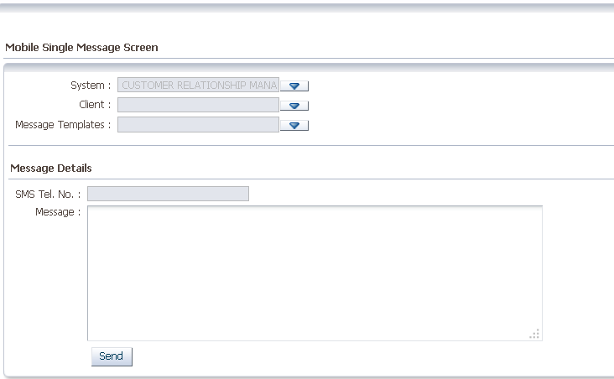

**Information required**

**System –**This is the system of which the message is related to

**Client-**Client of whom the message is to be send to

**Message templates-**The template of message to use

**Sms tel no-**The mobile number of the client

**Message-**The message to be send to the client

### Mobile Service Providers

This screen is used to define mobile service providers for purpose of doing payment through mobile

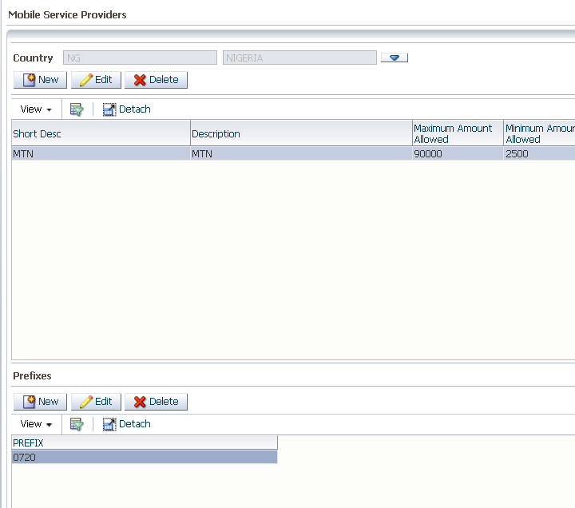

#### Adding a New Service Provider

Click new the screen below is displayed;

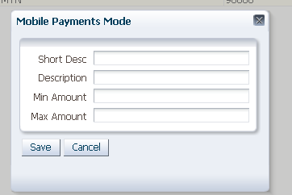

**Information Required**

Short Description –Short description of the service provider

Description-Name of the service provider

Min Amount-The minimum amount that can be transferred using mobile

MaxAmount-The Maximum amount that can be transferred using mobile

### Memorandum Setups

This screen is used to define all letters and memos templates.

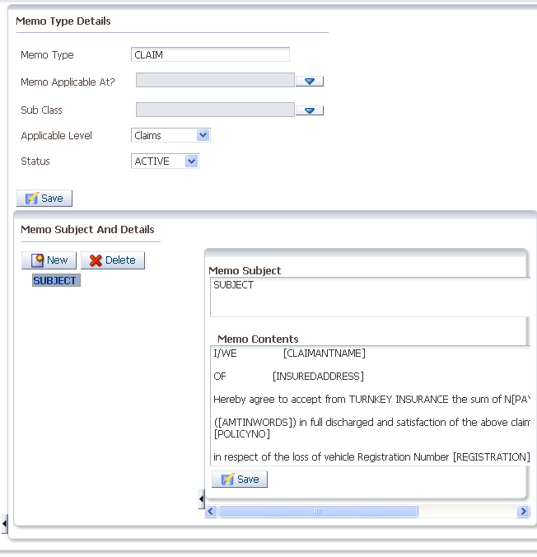

### Mail Settings

This is screen is used to setup email settings to allow sending of mail from the system

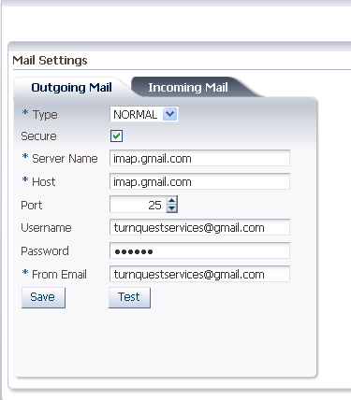

### SMS Settings

This screen is used to setup the setting of sms to allow sending sms from the system

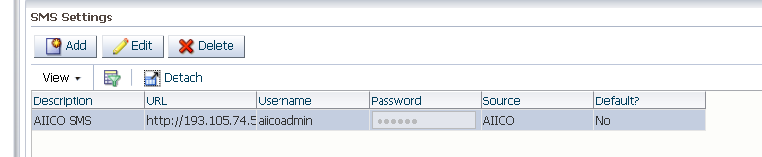

#### Authorize Messages

This screen is used to send sms messages in bulk

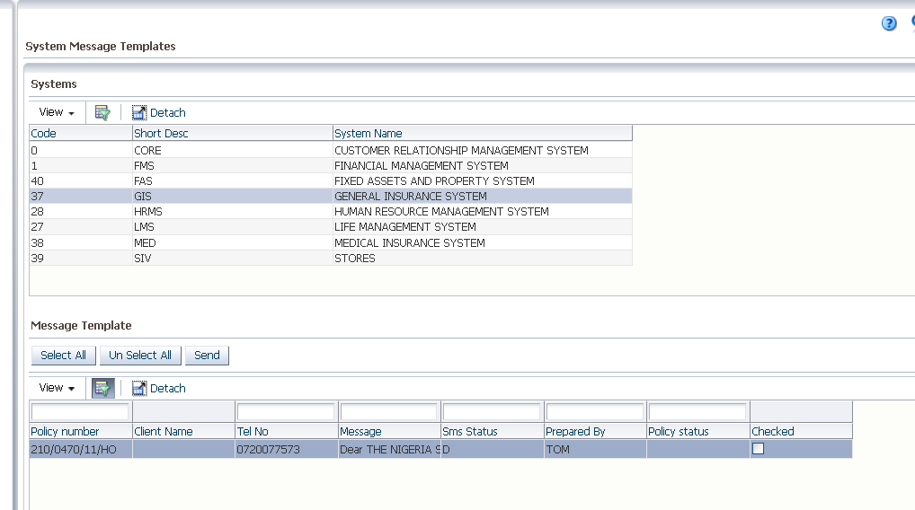

## BANK SETUPS

### [Banks](http://10.176.18.11:5000/CRMNEW1/faces/servReqCat.jspx?_adf.ctrl-state=zbvdt9cbe_4)

This screen is used to setup banks and bank branches

